Intro to Databases – Lab Report
Student Name: Qasim bin Mehmood
Student ID: AS25SYD006
Course: Intro to Databases
Date: May 29. 2026

Submitted to: Prof. Dinakar Bhotta

Table of Contents
1. Virtual Environment Setup 3
2. PostgreSQL Server Installation and Verification 3
3. PostgreSQL Server Startup and Connection 4
4. Creation of Database in PostgreSQL 4
5. Connecting to the New Database and Creating Tables 5
6. Inserting Sample Data and Verifying Relationships 6
7. Database verification through pgAdmin 8
8. Clean Shutdown of Environment and Database Server 8

1. Virtual Environment Setup
In this section, I created a dedicated Python virtual environment named venv_db_intro for this database lab. The environment isolates project dependencies from the global Python installation.
Commands used:
python3 -m venv venv_db_intro
source venv_db_intro/bin/activate
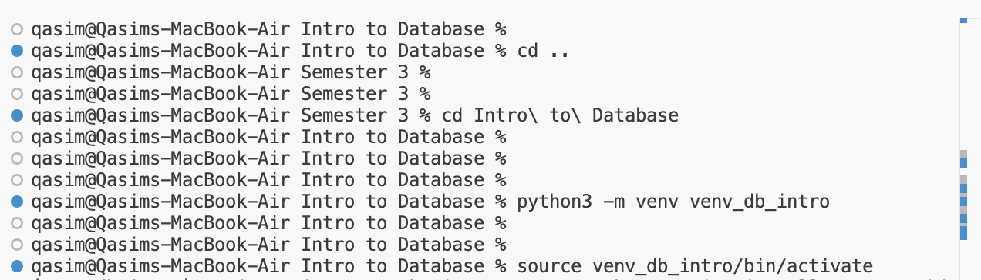

2. PostgreSQL Server Installation and Verification
PostgreSQL Server has been installed using homebrew for Mac
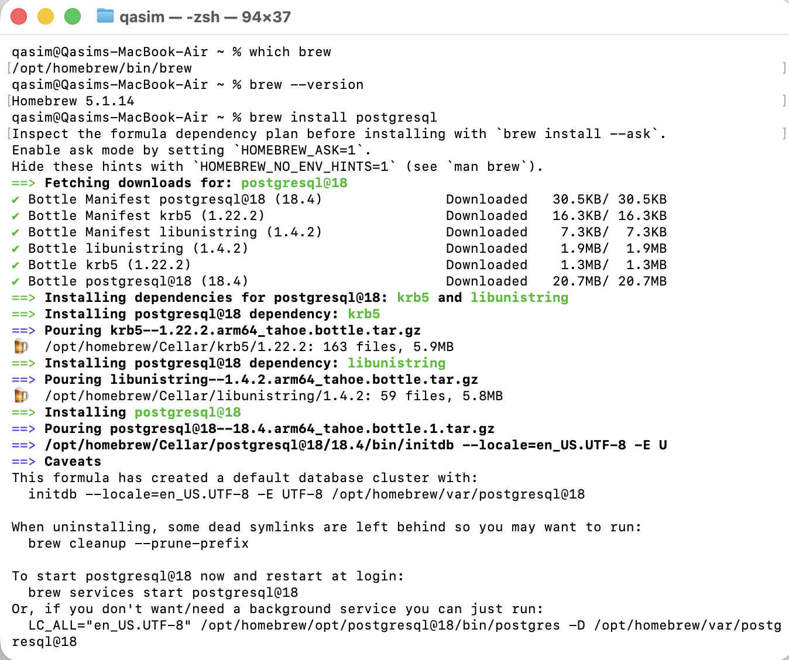
Installation has been verified:

3. PostgreSQL Server Startup and Connection
PostgreSQL 18 was installed on macOS using Homebrew, and the database server was started manually (not as a background service) to satisfy the assignment requirement of explicit control over the server lifecycle.
Commands used to start the PostgreSQL server manually:
LC_ALL="en_US.UTF-8" /opt/homebrew/opt/postgresql@18/bin/postgres -D /opt/homebrew/var/postgresql@18
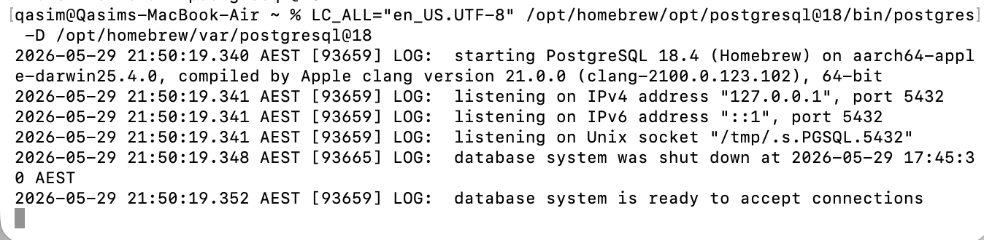

Commands used to connect to PostgreSQL from the terminal:
psql -U "$USER" -d postgres

4. Creation of Database in PostgreSQL
A new relational database was created for this lab using the psql command-line interface. The database name follows the assignment guideline and includes my name.
SQL command used:
CREATE DATABASE qasim_db_intro;
After creation, the list of databases was verified using the following command:
\list
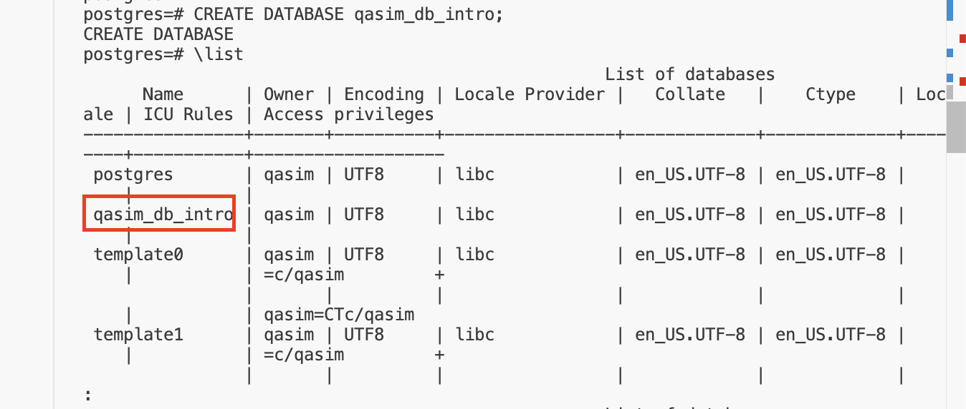

5. Connecting to the New Database and Creating Tables
The psql client was then used to connect to the newly created database qasim_db_intro. Within this database, three related tables were created to model a simple university enrollment system.
Command to connect to the new database:
\c qasim_db_intro;
SQL used to create the tables and establish relationships:
CREATE TABLE students (
student_id SERIAL PRIMARY KEY,
first_name VARCHAR(50) NOT NULL,
last_name VARCHAR(50) NOT NULL,
email VARCHAR(100) UNIQUE NOT NULL
);
CREATE TABLE courses (
course_id SERIAL PRIMARY KEY,
course_code VARCHAR(20) UNIQUE NOT NULL,
course_name VARCHAR(100) NOT NULL
);
CREATE TABLE enrollments (
enrollment_id SERIAL PRIMARY KEY,
student_id INT NOT NULL,
course_id INT NOT NULL,
enrollment_date DATE NOT NULL DEFAULT CURRENT_DATE,
CONSTRAINT fk_enrollments_student
FOREIGN KEY (student_id) REFERENCES students(student_id),
CONSTRAINT fk_enrollments_course
FOREIGN KEY (course_id) REFERENCES courses(course_id)
);
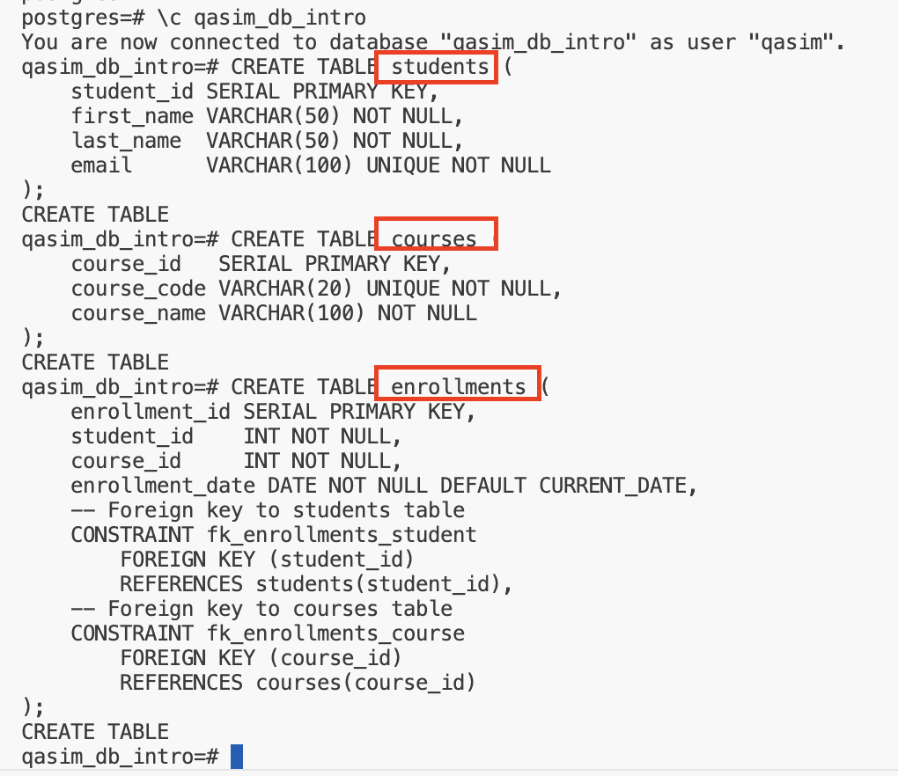

6. Inserting Sample Data and Verifying Relationships
To demonstrate that the relationships between the tables function correctly, sample data was inserted into each table. A join query was then executed to show students and their enrolled courses.
SQL used to insert sample data:
INSERT INTO students (first_name, last_name, email) VALUES
('Alice', 'Smith', 'alice.smith@example.com'),
('Bob', 'Jones', 'bob.jones@example.com');
INSERT INTO courses (course_code, course_name) VALUES
('CS101', 'Intro to Computer Science'),
('DB101', 'Intro to Databases');
INSERT INTO enrollments (student_id, course_id) VALUES
(1, 1),
(1, 2),
(2, 2);
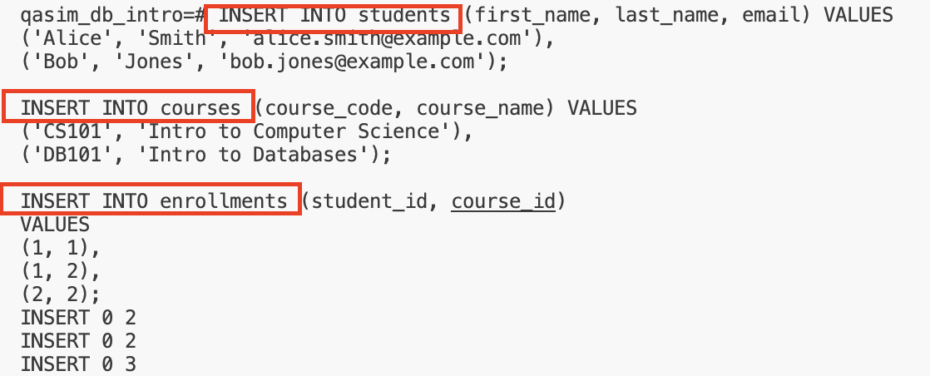
SQL used to verify the relationships via a join:
SELECT
e.enrollment_id,
s.first_name,
s.last_name,
c.course_code,
c.course_name,
e.enrollment_date
FROM enrollments e
JOIN students s ON e.student_id = s.student_id
JOIN courses c ON e.course_id = c.course_id;
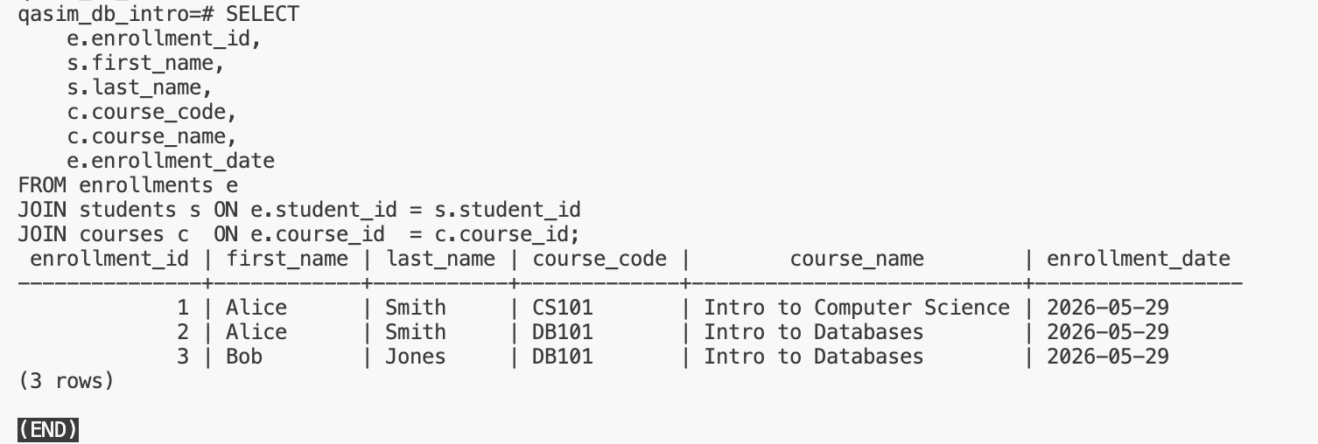

7. Database verification through pgAdmin
Database creation and working has also been verified by pgAdmin
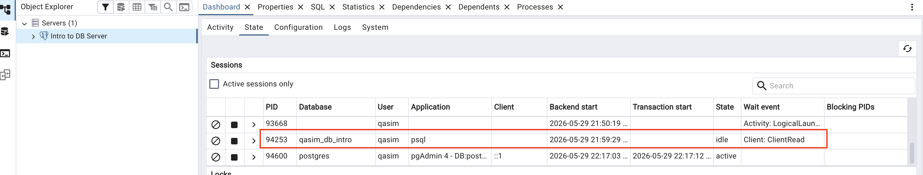

8. Clean Shutdown of Environment and Database Server
At the end of the lab session, all tools and services were shut down cleanly. The pgAdmin connection was closed, the psql client was exited, the Python virtual environment was deactivated, and the PostgreSQL server process was stopped.

